# C3- S7 PRACTICE

# Ex 1: Can I go to PNC?

1. I am a teacher and I am superman, can I go to PNC? no
2. I am not a teacher and not a student, can I go to PNC? NO
3. When can I go to PNC? 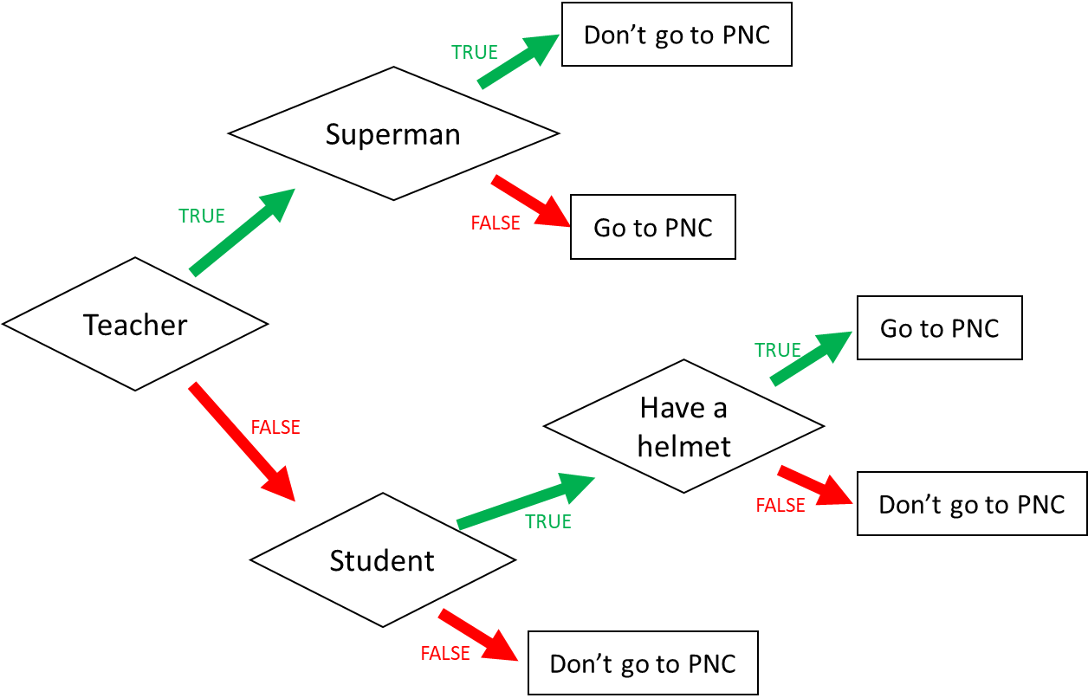ress the condition using a Boolean expression)

I go to PNC if:

1. Teacher and not supermen

2. Or don’t a teacher and student and have a helmet.

Ex 2: What do I eat?

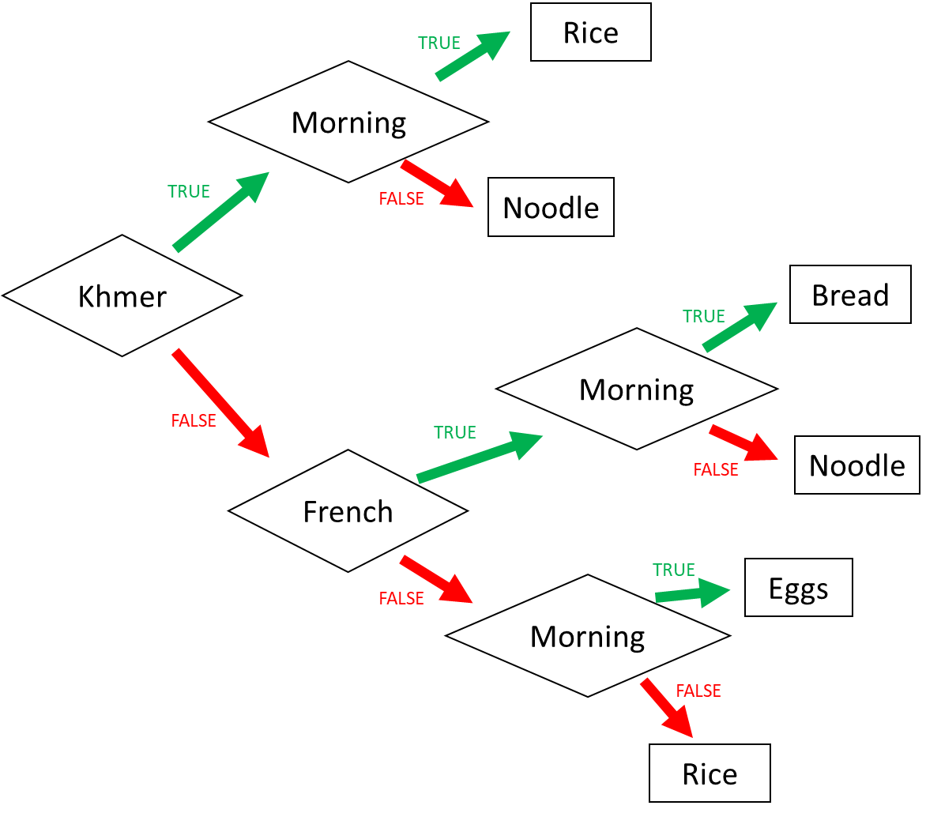

1. I am Khmer and it is the evening. What do I eat? noodle

2. I am French and it is the morning. What do I eat?Rread

3. I am American and it is the morning. What do I eat? Egg

4. When do I eat rice? (Express the condition using a Boolean expression)

I eat rice if:

1. (Khmer and morining) or

2. Dont’ khmer **and** don’t french **and** not morning.

Ex 3: Do I go to the pool?

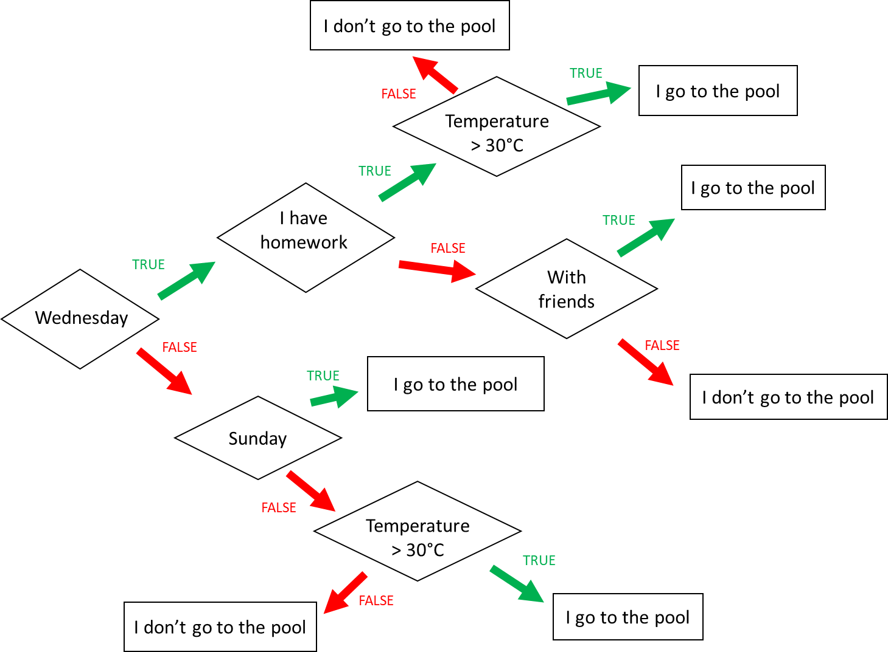

**Input 1 :**

* Wednesday
* Temperature = 31°C
* **Homework**

🡪 Do I go to the pool ? Yes

**Input 2 :**

* Monday
* Temperature = 35°C
* I have no friend

🡪 Do I go to the pool ? Yes

**Input 3 :**

* Wednesday
* I have **no** homework
* I’m with friends
* Temperature = 28°C

🡪 Do I go to the pool ? Yes

When do I go to the pool ? (Express the condition using a Boolean expression)

I go to the pool if :

I go to the pool if

Wednesday AND homework AND temperature > 30°C OR

Wednesday AND no homework AND friends OR

Sunday OR

Not Wednesday AND not Sunday AND temperature > 30°C

Ex4: Do I create a Facebook account?

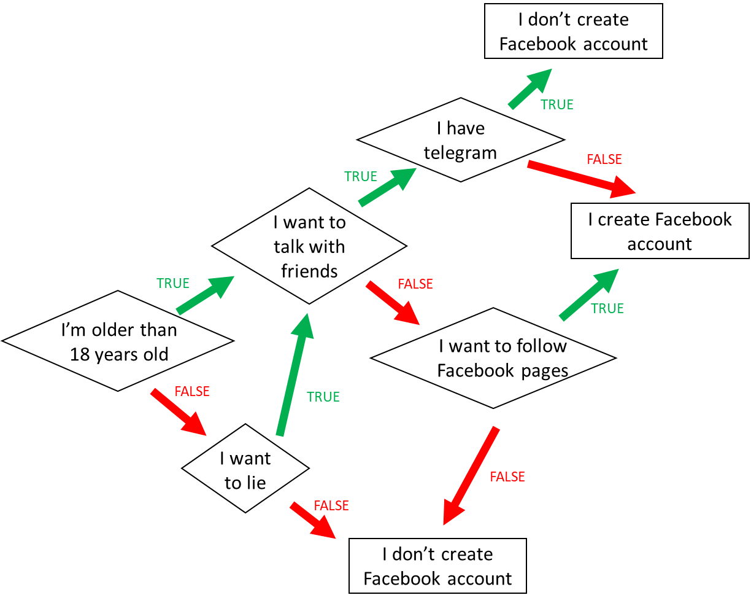

1. When do I create a Facebook account? (*Express the condition using a Boolean expression)*

I create facebook if:

I’m older than 18 years old **AND** I want to talk with friends **And** i haven’t telegram

OR I’m older than 18 years old **AND** I dont'want to talk with friends **AND** I want to follow facebook pages **or**

1. When **don’t I** create a Facebook account? *(Express the condition using a Boolean expression)*

I don’t create a Facebook account If :

I’m not older than 18 years old **AND I** don’twant to lie. OR

I’m older than 18 years old **AND** I want to talk with friends **And** i have telegram

OR I’m older than 18 years old **AND** I want to talk with friends **AND** I want to follow facebook pages

Ex5: Create the chart flow

**Q1** Complete the char flow to follow those rules:

* If I am a girl and it is sunny, I wear a skirt
* If I am a girl and it is not sunny, I wear jeans
* If I am a boy and it is sunny, I wear a short
* If I am a boy and it is not sunny, I wear jeans

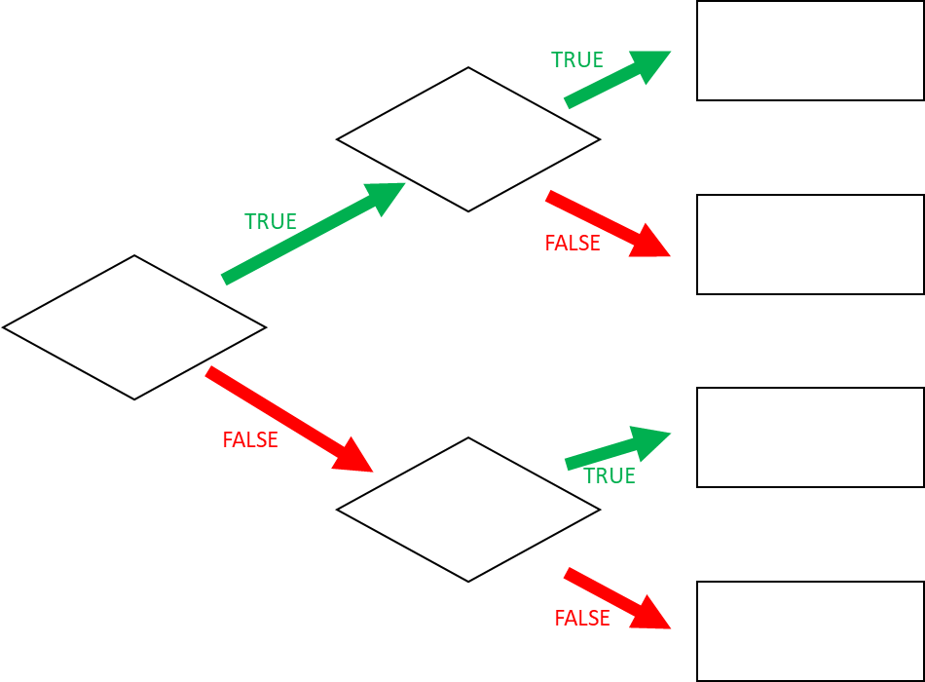

jeans

jeans

sunny

sunny

short

Skirt

Girl

**Q1** When do I wear jeans? *(Express the condition using a Boolean expression)*

Girl and not sunny.

Or not girl and not sunny.